**Software Requirement Specification for**

**Event Helper Building SystemVersion 1.0**

**Prepared by   Hoang Thanh Phong**

**Ho Vinh Duy**

**Chau Quoc Tuan**

**Nguyen Minh Tuan**

**From  SE05D GROUP 2 FPT university**

1. **Introduction**
   1. **Purpose**

The purpose of this document will provide the introduction, the sequence in each Feature, Functional Requirement on each service, the detail of data to operate on EHBS and non-functional requirement apply on EHBS.

* 1. **Document Convention**

No special typographical conventions are used in this SRS.

* 1. **Project Scope**

EHBS is a website that forwards allows service providers to introduce their service information for normal users who visit EHBS to research services and possibly request one or many services to serve their event.

* 1. **References**

This SRS references the Vision and Scope document for EHBS.

1. **Overall Description**
   1. **Product Perspective.**

EHBS is a brand new web-based that provides information of many services from many professional service provider companies, allows normal users to gather and compare the service fastly, and send requests to hire a particular service provided by EHBS service provider.

* 1. **User Classes and User Perspective**

**Guest**

A Guest is someone who comes to the EHBS.com website to view and search information of many services in the EHBS.

**Normal User**

A Normal User is someone who comes to the EHBS.com website to research the information of many services that publish in EHBS and may send the request to one or many services that will help them to operate their event. They also want to update or cancel the request.

**Service Provider**

A Service provider is someone who intends to post the service with a particular template from the EHBS library. They also want to access requests on their service and accept or reject requests on their service.

**Administrator**

An Administrator is responsible to investigate the possible incident on a cloud server, view the feedback from customers and usage of the system, research the behavior of visitors and normal account users then provide more friendly service.

* 1. **Operating Environment**

EHBS.com shall be compatible with standard web browsers on Windows, Mac, and Web-enabled smartphone platforms. Supported browsers are Internet Explorer 5, 6, 7, and above; Firefox 2 and 3; Opera 10 and 11; Google Chrome 10 and later.

* 1. **Design and Implementation Constraints**

CO-1: To reduce the price and human resources for building, upgrading, and maintaining one physical server, EHBS will be deployed on Azure cloud server service.

CO-2: To allow EHBS to operate on many platforms in the future, the Developer team will use C# and DOTNET/DOTNET Core framework to construct EHBS.

CO-3: To allow consistency on data, EHBS will use an SQL server to store data that exist on EHBS.

* 1. **User Documentation**

The developer shall provide the necessary documentation to enable an Administrator to perform the use cases listed in section 2.1.4 Administrator.

* 1. **Assumptions and Dependencies**

The detail in EHBS Vision Scope Document.

1. **Feature**
   1. **Service Manager**

**Description**:

* Service Manager is a feature that helps the service provider to modify the information of service, disable/re-enable a service , and create a new service.

**Stimulus/Response Sequences:**

* Service Provider chooses service on the service list.
* Service Provider clicks edit button.
* Service Provider edits information of service.
* Service Provider click save button.
* EHBS update information on EHBS database and reload.
* Service Provider click disable service.
* EHBS update the status of service to inactive.
* Service Provider clicks “Create New Service”.
* Service Provider enter the information of a new service, choose layout to display information of service.
* Service Provider click “Publish” button, EHBS insert the information of new service to EHBS database.

**Functional Requirement**

* This feature requires a Service Provider account, and service provider account has not expired(BR-8,BR-2).
* When a Service Provider creates a new service, the service provider must fill the name, description, image or video and select the price tag of the service, choose the operation schedule.
* When a Service Provider disables service, any pending request for disabled service must automatically be rejected by EHBS.
* When a Service Provider updates the price-tag of a particular service, the price tag will apply to requests that are created after the service successfully modified the database.
  1. **Service Request Manager.**

Description: Service Request Manager allows service providers to see requests from normal users. Service Providers can accept and reject the request.

**Stimulus/Response Sequences:**

* Service Provider clicks on the Request List button.
* EHBS show 30 recent pending requests.
* Service Provider clicks on request.
* EHBS pop-up modal with information of request.
* Service Provider clicks accept on request 🡺 EHBS update status of request to Accept.
* Service Provider clicks reject on request 🡺 EHBS update status of request to Reject.

**Functional Requirement:**

* This feature is only available to active service provider account (BR-4).
* Accept and Reject action only available to pending requests(BR-3, BR-6).
* EHBS must reload page and update the status of request when accept or reject the request.
* When click on Request List, EHBS display first 30 requests order by date and time.
  1. **Service Order Request.**

**Description**

* This feature allows normal user accounts to issue requests for service to service providers, modify the pending request, cancel the request.

**Stimulus/Response Sequences:**

* Normal users enter the fill service check-in time, service budget, total attendant in service.
* Normal user click send request of service.
* EHBS validates requests and notifies user results after validating the request.
* EHBS inserts the new request to the EHBS database, when the request is validated.

**Functional Requirement**:

* This feature is only available to normal user accounts.
* Service check-in time must be larger than 2 hours from the time request was recorded BR-14.
* When a request is successfully created, the request history must be updated when the request is successfully created.
  1. **Services Report**

**Description:**

* Service Report will allow service providers to construct the report about the usage of a particular service in a specified period.

**Stimulus/Response Sequence**

* The service provider clicks on the create report button ⇒ EHBS shows a list of services that belong to this account .
* The service provider selects the service on this list and clicks on the submit button ⇒ EHBS gathers the information of request of services based on the service selected in the report request form and generates the file of the form to be exported.
* EHBS show redirects the service provider to the report that is ready to be exported to service provider devices.

**Functional Requirement:**

* Only active service provider accounts can generate the report.
* EHBS requires a service provider account to pass a captcha challenge when they submit the request report form.
* EHBS will require the service provider account to re-enter the password and input the verification code from the email (BR-9).
* EHBS must only create reports with the period of six months before the current month due to business rule BR-14.
  1. **Service Scanner**

**Description:**

* The Event Service Scanner feature will provide suggestions about the most comfortable services for a particular metric provider by normal users.

**Stimulus/Response Sequences:**

* Normal users select the range of their budget, and the kind of service that may operate in the event.
* Normal users click the find button.
* EHBS shows the list of services that have all properties selected above.

**Functional Requirement:**

* EHBS shall show options about the range of price, the kind of service available in the system’s database for normal users to select.
* EHBS shall select the active service in the system that has properties match to select options from normal users.
* EHBS shall show a section for each service that has been selected after scanning. Each section on the result page shall have the following information: service name, service provider information, and service descriptions.
  1. **Register and login**

**Description:**

* This feature allows guests to create a new EHBS’s normal account.
* Guests must have an account and must be logged-in to EHBS then they can pre-order service to the service provider if they log in with a normal user account or to create the service, and manage the services and service requests to their service.

Functional Requirement:

* This feature only creates a normal user account.
* EHBS must check the unique email that registers in the register form.
* EHBS must send the active account email that registered with the new normal user account.
* A new Normal User Account defaults to be inactive.
* EHBS will lock the account after 15 minutes if the guest enters the wrong password 5-times row.
  1. **Feedback to Service:**

**Description:**

This feature will allow the normal user account to give the feedback on service to the Service Provider after each request has been accepted.

**Stimulate/Response Sequence:**

* Normal User Account chooses a service to send the feedback.
* Normal User Account submit the point and note in the feedback.
* EHBS records the feedback to the EHBS database.

**Functional Requirement:**

* Only available on the normal user account.
* Allows a normal user account to send the feedback only on the service that is already requested by this account.
  1. **Check-in Service**

**Description:**

After the request has been successfully accepted, the normal user of this request will receive the check-in code. The normal user is required to show this code to the service provider, the service provider will scan the code by capturing this code and upload to EHBS.

**Stimulate/Response:**

* Service provider selects the “check in” requests button.
* Service providers scan pictures of code provided by customers.
* EHBS shows the result after processing the scanning check-in code.

**Functional Requirement**:

* Show error when scan code is already used.
* If check in code is valid, check in code.

**Description**

* Allow Service Provider to ensure that the service is require

1. **Data Requirements**
   1. **Logical Data Model**

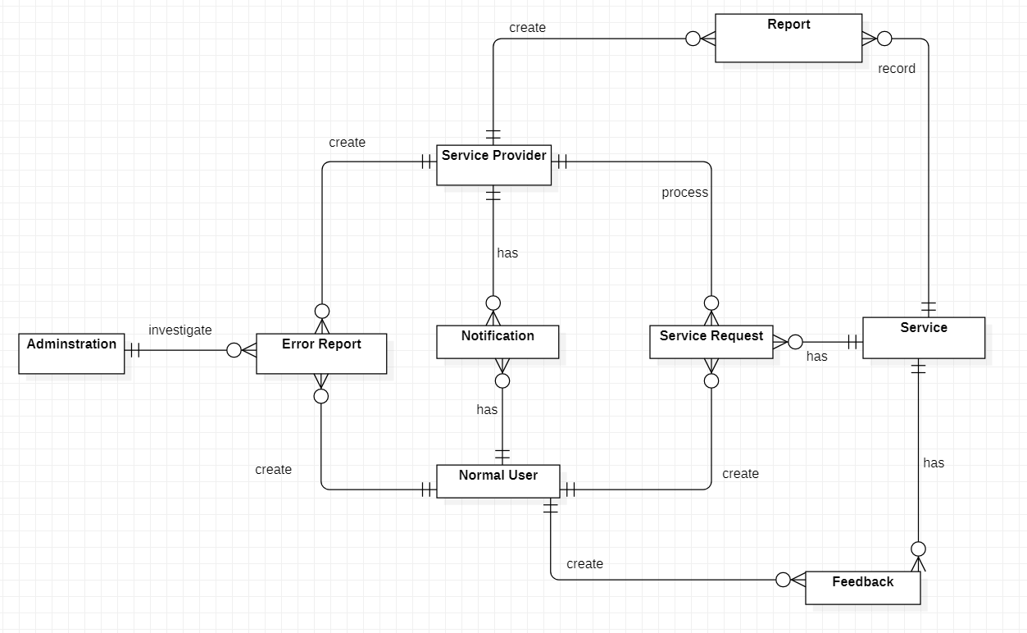

* 1. **Data Dictionary**

|  |  |  |  |  |
| --- | --- | --- | --- | --- |
| Data Element | Description | Composition or Data type of elements | Length | Value |
| Normal User email | Email bind to normal user account | string | 100 |  |
| Normal User fullname | Name of user own normal user account | string | 50 |  |
| Normal User Password | Password of normal user account | alphanumeric | 8 -> 32 |  |
| Normal User Date of Birth | Birthdate of user. | dd/mm/yyyy |  |  |
| Service Provider ID | Identification for service provider account | alphanumeric | 8-32 |  |
| Service Provider Organization | Name of Organization that own service provider account | Alphanumeric | 100 |  |
| Expire Date | The date of service provider account will expire | dd/mm/yyyy |  |  |
| Service Provider Email | Email of Service Provider | string | 100 |  |
| Service Provider phone number | Phone of Service Provider | numeric | 8-11 |  |
| Request ID | Identification of the request create in EHBS | alphanumeric | 20 |  |
| Request Service ID | Identification of the service to be requested | alphanumeric | 20 |  |
| Request Check-in date. | The date normal user request to use the service. | dd/mm/yyyy |  |  |
| Request Budget | Budget normal user expect to pay for service | float |  |  |
| Request Status | Status of current request | integer | 20 | 0 – Not Processs.  1- Accepted.  2 – Rejected.  3-Canceled |
| Request Total Attentdant | The number of attendant to take part in the event | Integer |  |  |
| Request User ID | Email of normal user that create request. | string | 50 |  |
| Service ID | Identification of service in EHBS | string | 20 |  |
| Service Name | Name of the service in EHBS | string | 100 |  |
| Service Price-Tag | Range of service budget | string | 100 |  |
| Service Description | Description of Service | string | 500 |  |
| Service Schedule | Service Operate timetable | string | 50 |  |
| Error report ID | Identification of error report | alphanumeric | 30 |  |
| Error report problem | Problem in report | alphanumeric | 255 |  |
| Error report datetime | Datetime error existed | hh:mm:ss dd-MM-yyyy |  |  |
| Notification ID | Identification of notification | Alphanumeric | 255 |  |
| Notification Content | The content of notification | string | 255 |  |
| Notification Datetime | The datetime notification has been created | hh:mm:ss dd-MM-yyyy |  |  |
| Notification Receiver | The Identification of service provider or service normal user or admin to recevie this notification | string | 255 |  |
| Report ID | Identification of report | alphanumeric | 30 |  |
| Report Title | Title of report | String | 50 |  |
| Report Service | Identification of Service to be report | String | 20 |  |
| Report Receiver | Service Provider allow to see report | String | 20 |  |
| Report Date | Date create report | String | 20 |  |
| Report Directory-URL | Uri or Url path of report | String |  |  |

* 1. **Report**

|  |  |
| --- | --- |
| **Report ID:** | EHBS-RPT-1 |
| **Report Title:** | Services Request Usage Report. |
| **Report Purpose:** | The service provider wants to see a list of request to one or many services in a particular period of the time |
| **Priority:** | Medium |
| **Report Users:** | Service Providers |
| **Data Sources:** | Database of previous service requests. |
| **Frequency and Disposition;** | The report is generated on-demand from the service provider. Data in the report is static. The report is displayed on the user's web browser screen on a computer, tablet, or smartphone. It can be printed if the display device permits printing. |
| **Latency:** | A complete report must be displayed to the service provider within 1 minute  after it is requested. |
| **Visual Layout:** | Landscape mode |
| **Header and Footer:** | The report header shall contain the report title, Service provider's name, name of service to be reported, and date range specified. The report footer contains the page number. |
| **Report Body:** | Fields showed and column headings:  ID of the request  status of the request when the report was created.  Expected budget of the request.  Create Date of the request.  Expected Date to operate the service of the request.  Average number of requests in one day.  Average number of requests to be processed in one day.  Number of accepted requests.  Number of rejected requests by service providers.  Number of requests to be canceled by normal users.  Number of the requests that check-in success.  Number of the request that check-in fails.  Selection Criteria: date range specified by Service provider,  and service specified by the service provider.  Sort Criteria: order by service name and create the time for each request. |
| **End-of-Report Indicator:** | None |
| **Interactivity:** | None |
| **Security Access Restrictions:** | A service provider retrieves only requests for service that he/she creates. |

* 1. **Data Acquisition, Integrity, Retention, and Disposal**

Each contract has a one-year term, so that after one year if service providers are not renewed their contract, the EHBS will disable any services that are managed by them to receive and accept the demand from normal users.

Each request will exist for a maximum of 6 months in EHBS after that EHBS will remove these requests from the EHBS database.

1. **External Interface Requirements**
   1. **User Interfaces**

UI-1: Each page must contain a navigation bar that displays on top of the screen and sticks in there when the user scrolls on the page.

UI-2: The layout of the page must correspond to the screen of the current device.

* 1. **Software Interfaces.**

Web browser: Chrome, Opera, Internet Explorer.

Database: SQL server 2014, Amazon Relational Database Service.

Development tool: Visual Studio 2017 or later,  dotnet framework 4.5 or above.

Database cache: Redis.

* 1. **Hardware Interfaces.**

Not identified.

* 1. **Communication interfaces.**

EHBS shall send the notification to the service providing an email when a new request for their service arrives.

EHBD shall send a notification email when the request has the agreement from service providers or an active account email for each new normal account or confirmation emails for each time the user requires to change the account password.

1. **Quality Attribute**
   1. **Usability Requirements**

USE-1: EHBS shall allow a normal user to retrieve the list of the request with a single click.

USE-2 Almost normal users can successfully create requests on service without errors about the network on their first try.

* 1. **Performance Requirements**

PER-1 EHBS shall accommodate a total of 1000 normal users or 300 service providers from 8 am to 11 pm.

PER-2 EHBS shall process the report request from the service provider within 10 seconds on each of them.

* 1. **Security Requirements**

SER-1 Users shall be required to log in to the EHBS for all operations except searching and view services.

SER-2: Service providers must authenticate their identities through re-enter the password and verification code with the new account that is sent to their email.

SER-3: If the service provider enters the wrong password 5 times - the account automatically locks in 15 minutes.

1. **Appendix**
   1. **Use Case Diagram**

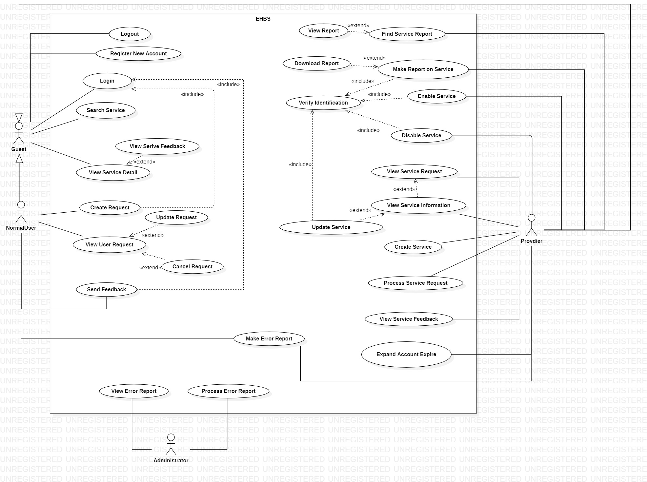

* 1. **Class Diagram.**

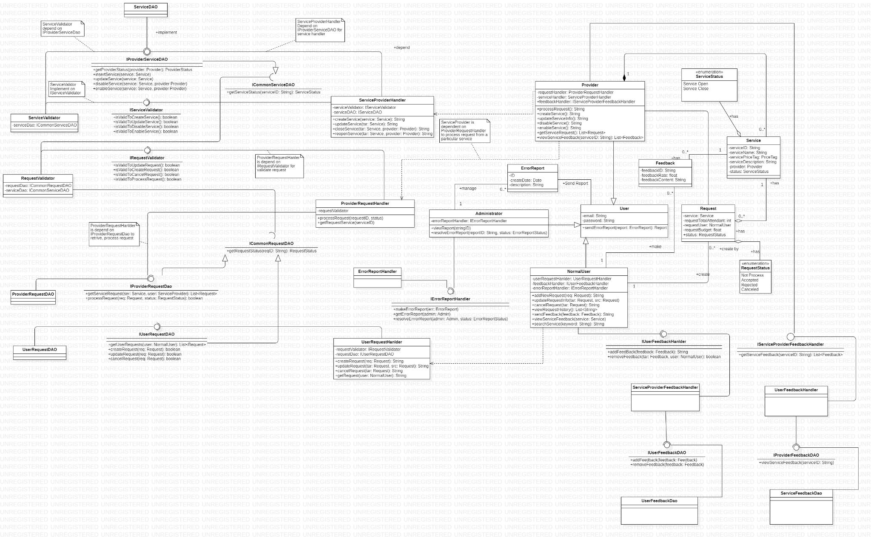

* 1. **Sequence Diagram**
     1. **Process Request.**

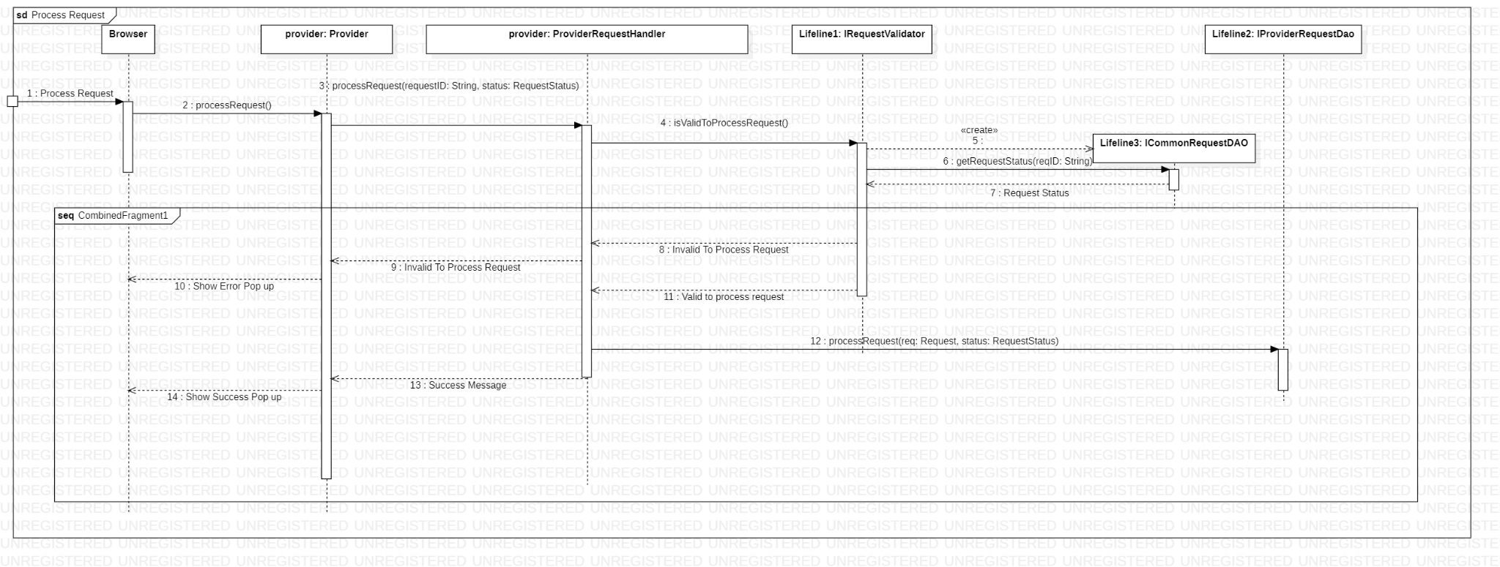

* + 1. **Close Service**

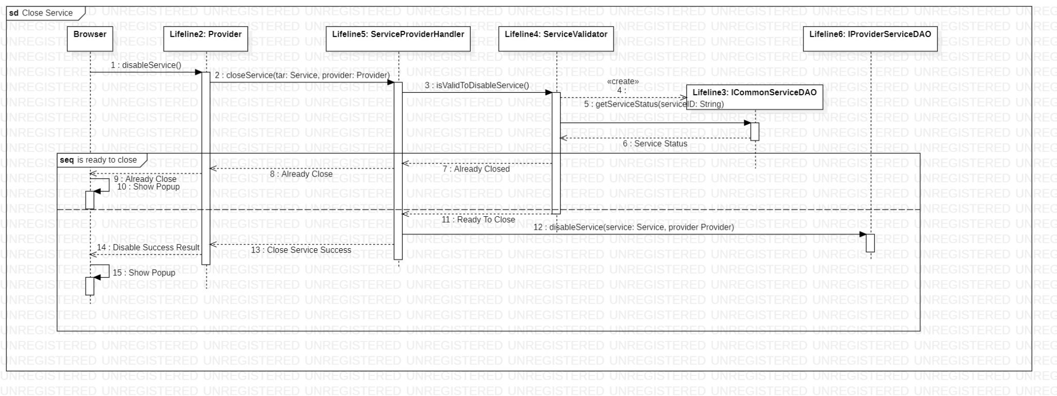

* + 1. **Create Request**

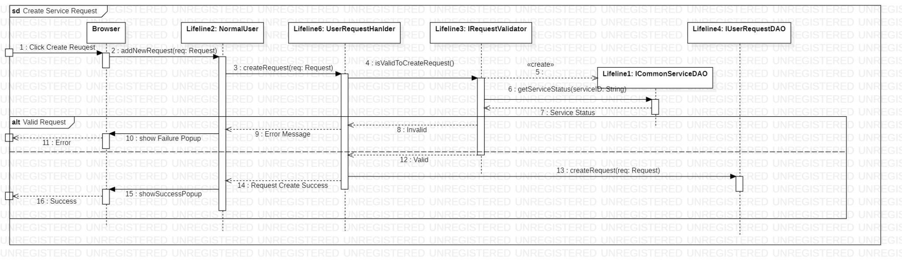

* + 1. **Create Service**

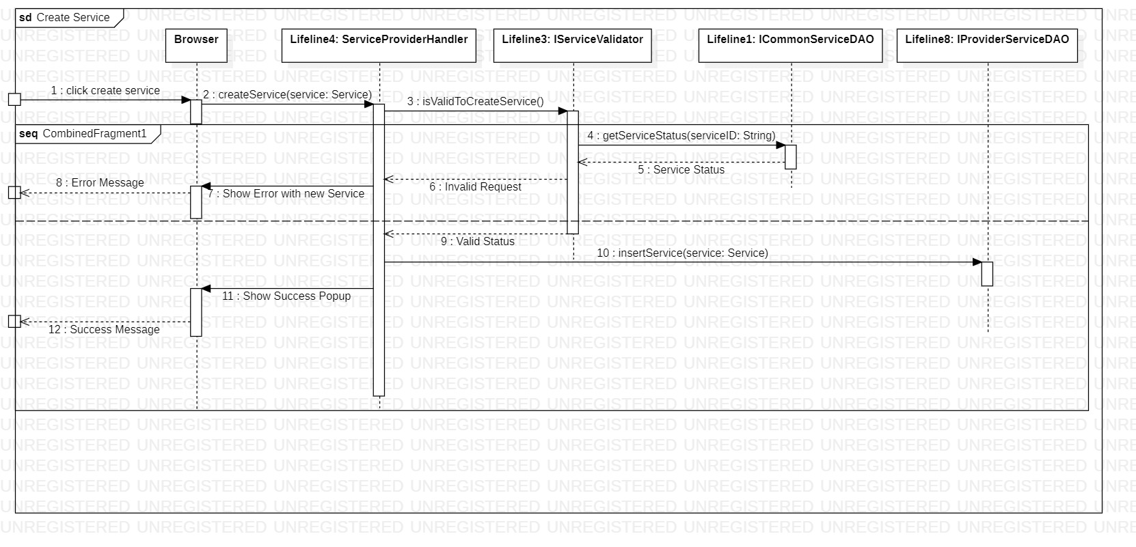

* 1. **Screen Flow**

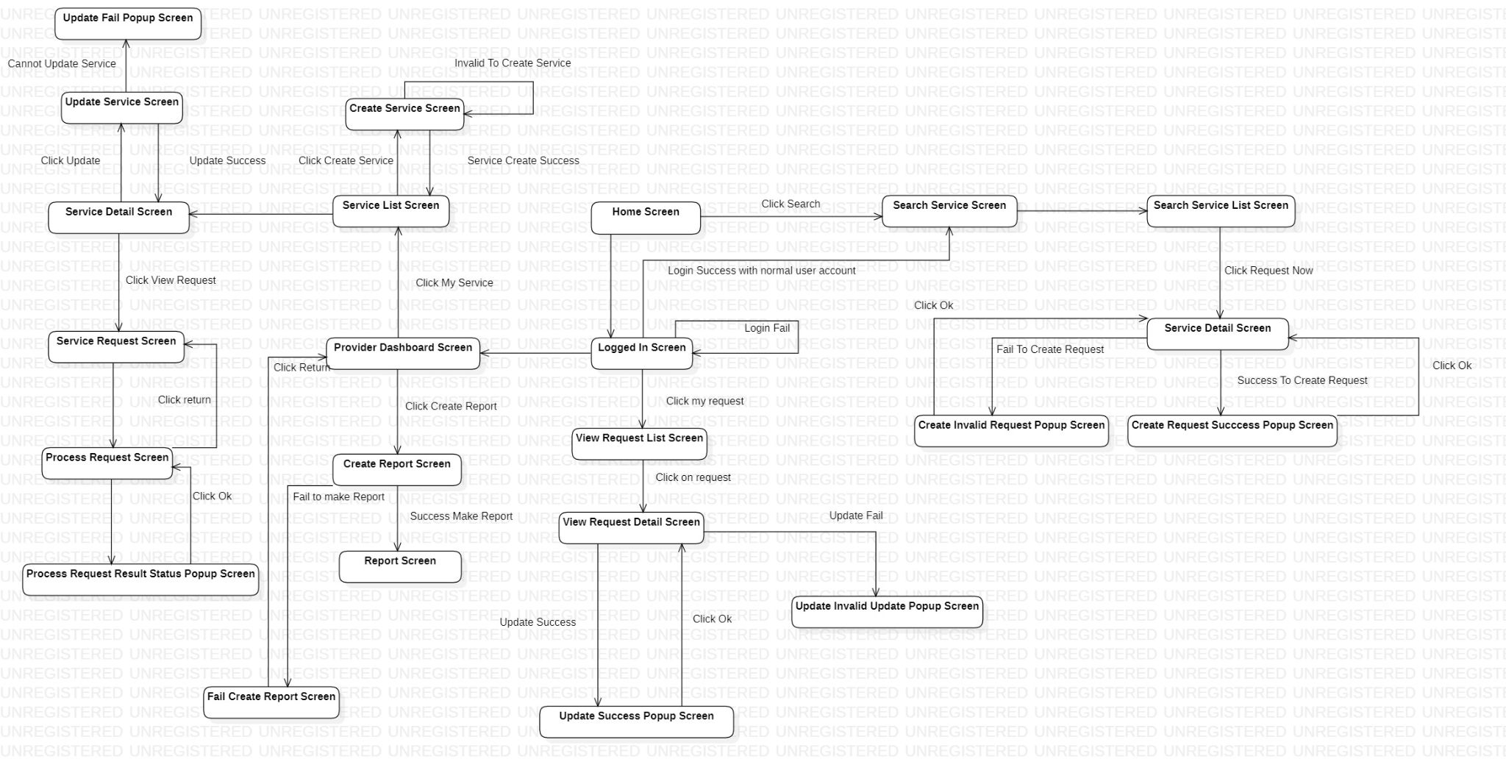

* 1. **Wire Frame**

**Search Page**

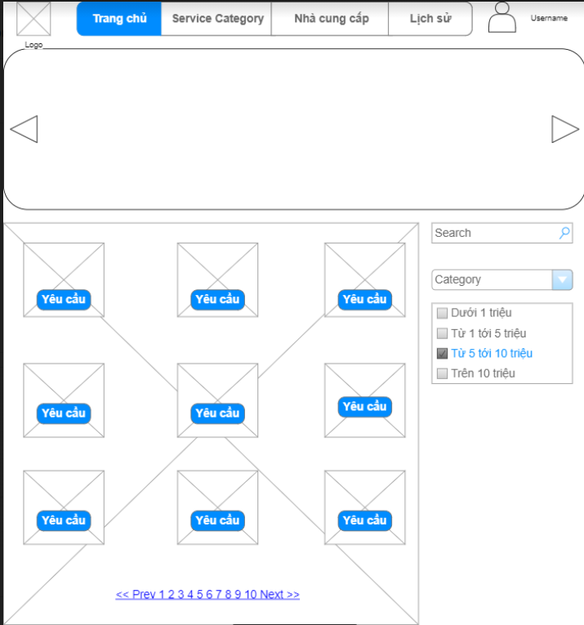

**Service Detail Page**

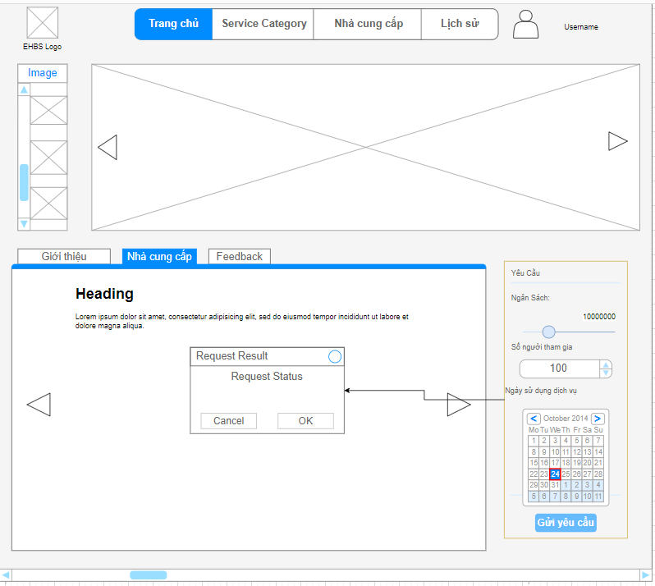

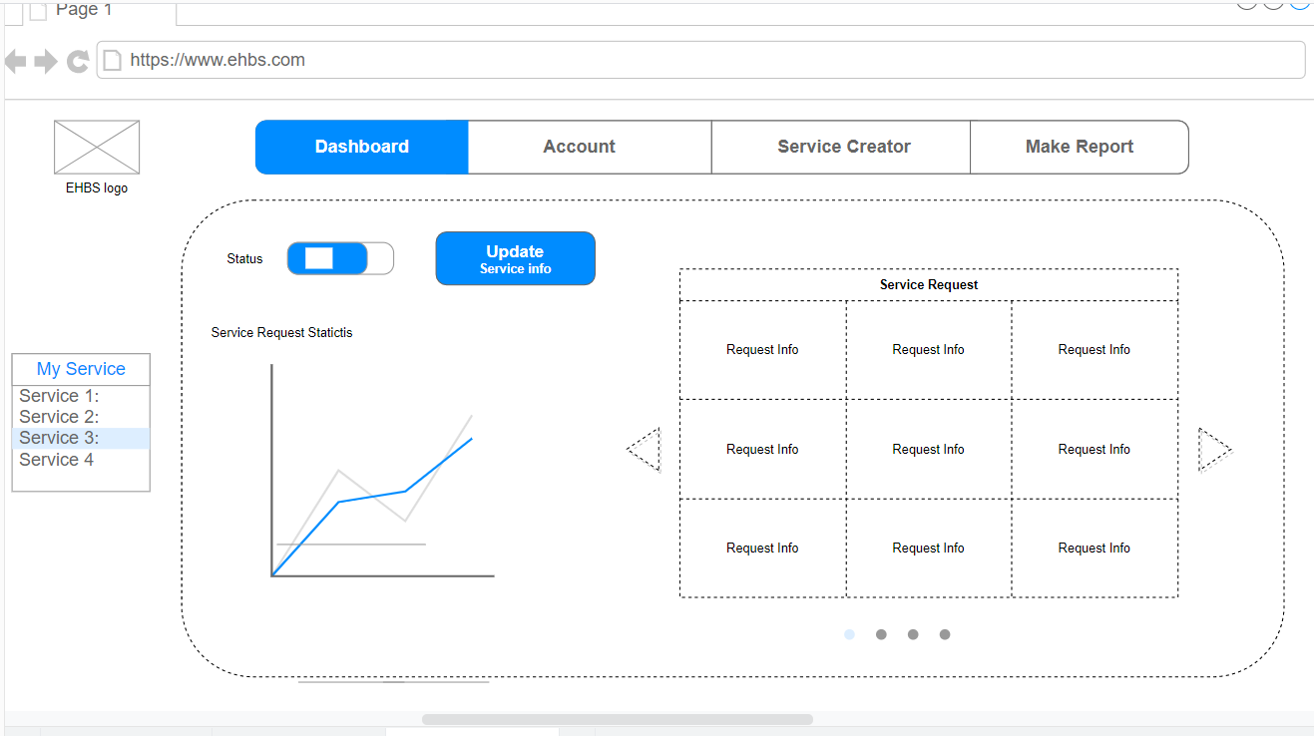

* 1. **Context Diagram**

